**Hotel Booking Analysis**

**By**

**Praveen Sikarwar**

**Punam Nagrale**

**Boncheruvu Teja**

**Rishi Chaturvedi**

**Kishor Kunal**

**Abstract:**

Hotel industry is one of the most volatile and highly competitive industries. The bookings in the industry depends on a lot of factors day of week, season, costs, accessibility, facilities, etc.

In this EDA, we analyzed the data provided to understand and predict behavior of customers like when customers are booking more, cancellations, preferred meal type, repeated customers, etc.

***Keywords:*** *Hotel, bookings, cancellations, analysis, visualization and graph.*

**1. Problem Statement**

As the hotel industry is very volatile, it very important for the hotel owners to should make use of the historical data of the hotel bookings. Analyzing the past data would help them draw actionable insights and stay ahead of their peers in the industry.

However, as there is a lot of data coming from different platforms and sources, it is very difficult for the hotel owners to organize the data and analyze it.

Here, our main objective is to analyze the data to understand the customer behavior and other important factors that govern hotel bookings and get insights into hotel management.

The analysis would help in predicting the customer preferences in terms of hotels, timings of booking, meal type, cancellations, etc. It would also help in designing strategies for campaigns and hotel management.

**2. Work Flow**

Our approach for analyzing the data is to divide workflow into three parts:

1. Data collection and understanding
2. Data cleaning
3. Exploratory Data Analysis (EDA)

**2.1 Data Collection and Understanding**

We have a data set in the csv format that contain historical data related to the hotel industry. We have loaded the data file and tried to understand the data present by using different attributes such as head(), tail() and info() attribute.

The data set contain information such as type of hotels, when the booking was made, length of stay, repeated guests, the number of adults, children, and/or babies, and the number of available parking spaces, among other things. Then we created a copy of the original data set in order to perform data cleaning.

**2.2 Data Cleaning**

Data cleaning helps to remove the redundant and useless data from the data set. After creating a copy, we performed data cleaning by deleting the duplicate and null values from the copy data set.

**2.3 EDA**

In the EDA process, we tried to find different trends like from which country most number of guests are coming, which type of hotels are making more revenue, monthly wise bookings over the year, how many customers are asking for car parking space, week and weekend stays, most preferred meal type, etc. We also used different graphs in the process by visualizing the data as required to effectively analyse it and get insights.

**3. Observations**

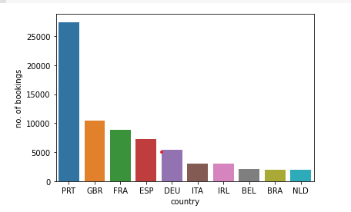

More number of guests are coming from Portugal (PRT), followed by GBR, France and others.

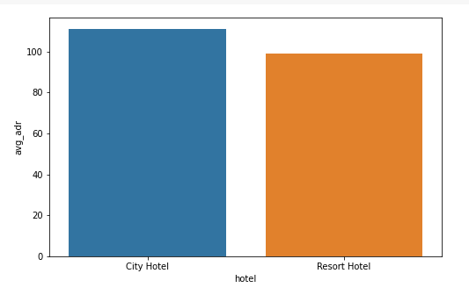

The average daily revenue in city hotels is more as compared to that of resort hotels.

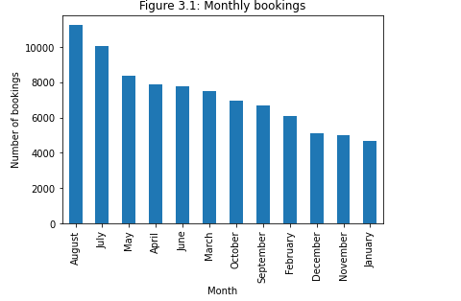

August month seems to very busy with a greater number of guests followed by July, May, April and others. January is the month with least number of customers.

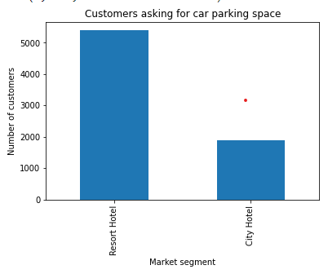

More number of customers from resort hotels are asking for car parking space.

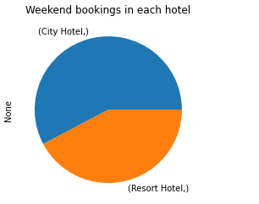

The weekend bookings in city hotels are more than that of resort hotels.

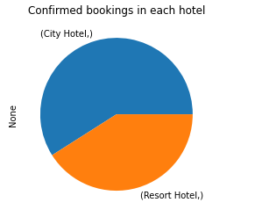

The total number of confirmed bookings in city hotels is more than that of the resort hotels.

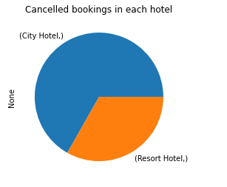

The total number of cancelled bookings in city hotels is more as compared to resort hotels.

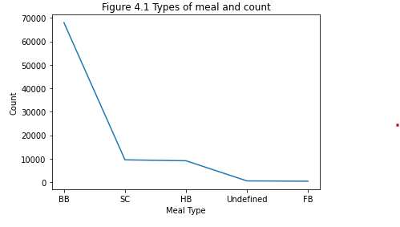

BB is the most preferred meal type among all.

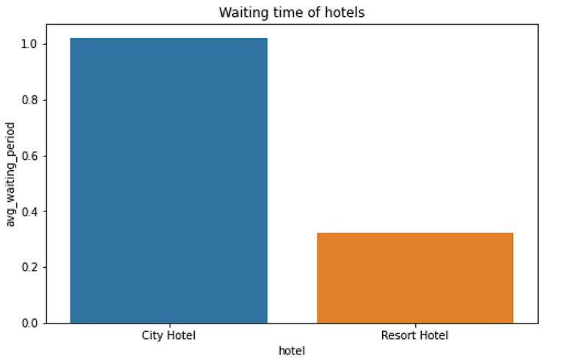

The waiting time in city hotels is more than that of the waiting time in resort hotels.

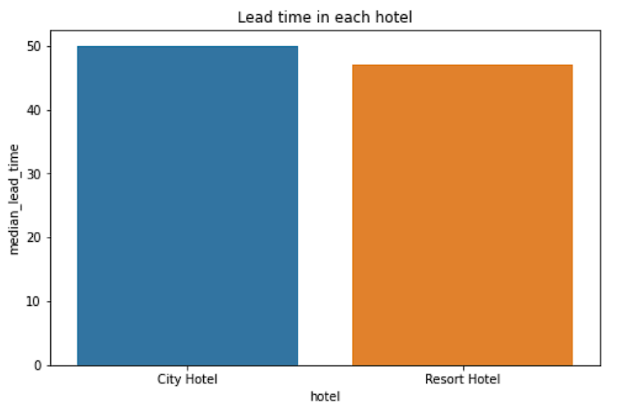

Lead time in city hotels is slightly higher than that of resort hotel lead time.

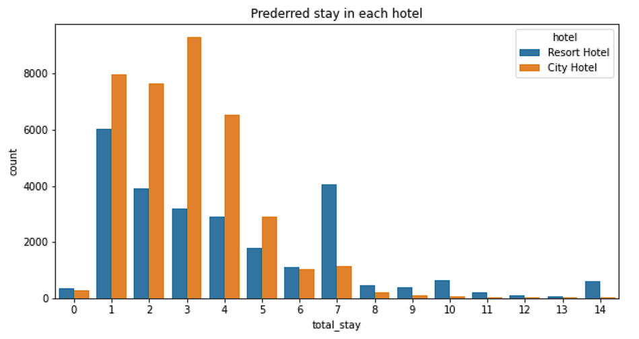

People generally prefer to stay less than 7 days and mostly choose city hotel as compare to resort hotel.

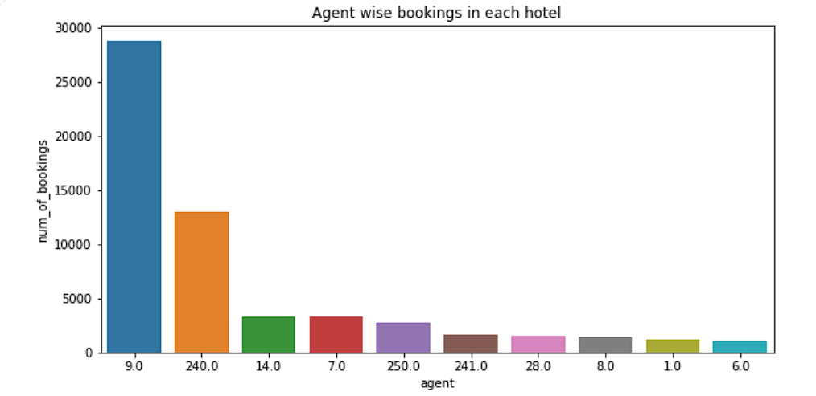

Most of the Booking are made by the agent having ID No. 9.0

Preferred room type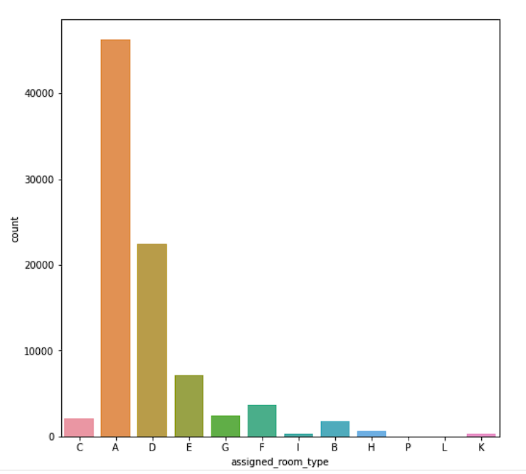

Most preferred room type is ‘A’.

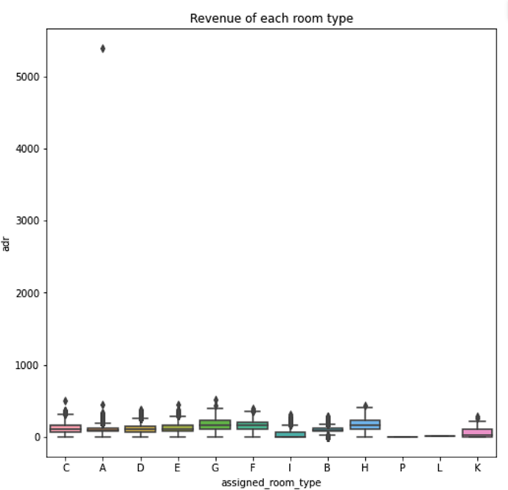

More revenue is generated by room type ‘G’

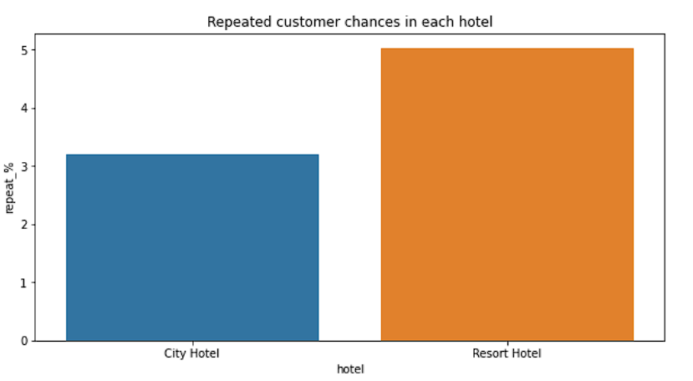

Resort hotels have more chances of repeated customers.

**4. Graphs Used**

We used different types of such as bar graphs, pie chart and line graph to understand, analyse and visualize the data set.

**4. Conclusion**

From the above observations, we can conclude that:

* City hotels are attracting more customers than resort hotels
* Cancellations are also more in city hotels than resort hotels
* The gap in the average daily revenue of both hotels is less as compared to the number of bookings
* Bookings are more in August and least in January. So, the hotel management should be prepared to handle the heavy load in August.
* More customers are asking for car parking space in resort hotels. So, the resort hotel management should consider leaving more space for car parking.
* As far as the meal type is considered, more number of customers are choosing BB (Bed and Breakfast).
* Most preferred stay length in each hotel is ‘7’ days.
* Resort hotels have more chances of repeated customers than that of city hotels.